1/Create a database called "contact"



2/Create a collection called "contactlist"



3/ Insert persons in "contactlist" :

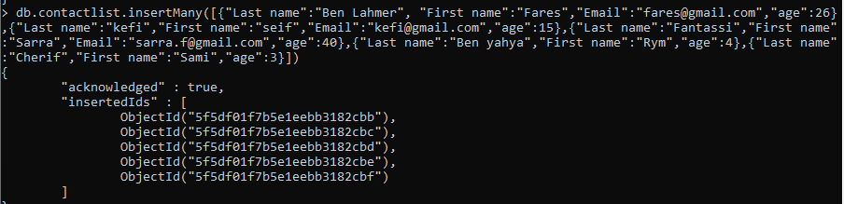

4/ Display all the contact list



5/ Display all the information about only one person using his id



6/ Display all the contact list having age>18

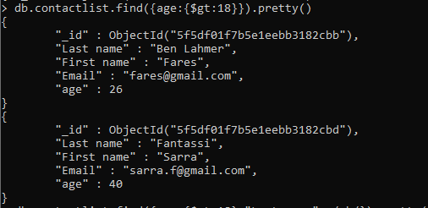

7/ Display all the contact list having age>18 and name containing "ah"

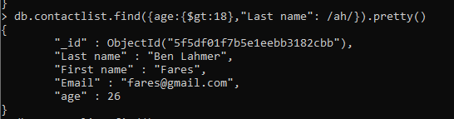

8/ Change the contact first name of "kefi Seif" by "Kefi Anis"



9/ Delete the the contact list having age < 5



10/ Display all the contact list

